PROGRAM 2 : Multi-Product Price Fluctuation Analysis
1. Problem Statement
Develop a Python program to analyse area-wise water distribution across several days. The program compares the actual water supply with the water demand of different areas, calculates daily and total shortages, compares distribution levels, and identifies the most underserved area.
The program uses Python concepts such as computational thinking, algorithms, flowcharts, pseudocode, variables, data types, operators, conditional statements, loops, strings, pattern generation, lists, nested lists, tuples, tuple operations, and unpacking to generate a clear water distribution fairness report.
2. Objectives
- Store the water demand and actual supply of different areas across multiple days.
- Calculate the daily water shortage for each area.
- Calculate the total demand, total supply, and total shortage for each area.
- Compare the percentage of demand fulfilled in each area.
- Identify the most underserved area based on its demand fulfilment percentage.
- Display area-wise water distribution data in a formatted table.
- Use Python lists, nested lists, tuples, loops, operators, and conditional statements.
- Suggest which areas should receive priority in future water distribution.
3. Assumptions
The following assumptions are used for this case study.
Item | Assumption
Number of areas | 3
Number of days | 3
Unit of measurement | Kilolitres (kL)
Water demand | Given separately for each area and day
Actual supply | Given separately for each area and day
Water shortage | Demand − supply, with a minimum shortage of zero
Total demand | Sum of daily demand for an area
Total supply | Sum of daily supply for an area
Fulfilment percentage | Total supply ÷ total demand × 100
Most underserved area | Area with the lowest fulfilment percentage
Input data | Assumed sample values for demonstration
The program assumes that water supply values are non-negative. The sample data is illustrative and does not represent actual municipal water statistics.
4. Computational Thinking
Computational thinking helps us solve the water distribution problem step by step.
- Decomposition: Divide the problem into calculating daily shortages, total demand, total supply, and fulfilment percentages.
- Pattern recognition: Identify areas that repeatedly receive less water than they require.
- Abstraction: Focus on the important data: area names, daily demand, actual supply, and shortage.
- Algorithmic thinking: Follow a sequence of calculations to compare areas and identify the most underserved area.
5. Algorithm
- Start the program.
- Create a list of area names and a tuple of day names.
- Store the daily water demand and actual water supply in nested lists.
- Initialize lists to store total demand, total supply, and total shortage.
- Use nested loops to visit each area and each day.
- Calculate the daily shortage by subtracting actual supply from demand.
- Calculate total demand, total supply, and total shortage for each area.
- Calculate the demand fulfilment percentage for each area.
- Compare the fulfilment percentages of all areas.
- Identify the area with the lowest fulfilment percentage.
- Display the daily shortages and the area-wise summary in a formatted table.
- Display the most underserved area and stop the program.
6. Flowchart
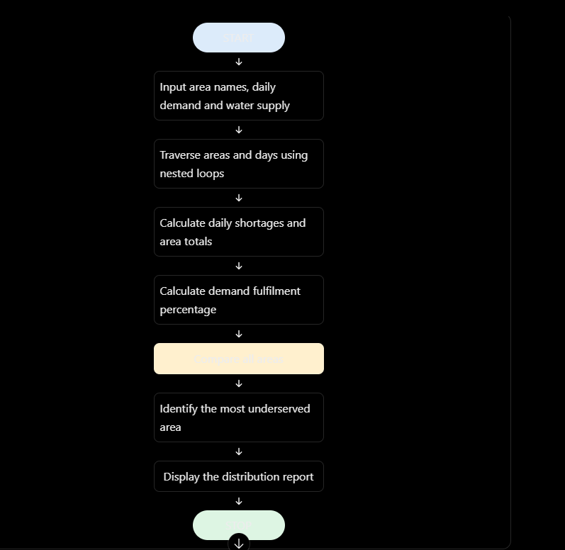

7.PESUDOCODE
BEGIN

SET area_names
SET day_names
SET water_demand
SET water_supply

FOR each area
SET total_demand = 0
SET total_supply = 0
SET total_shortage = 0

FOR each day
shortage = MAX(0, demand - supply)

ADD demand to total_demand
ADD supply to total_supply
ADD shortage to total_shortage
END FOR

fulfilment = total_supply / total_demand * 100
STORE area totals and fulfilment
END FOR

FIND area with lowest fulfilment percentage

DISPLAY daily shortages
DISPLAY area-wise totals and percentages
DISPLAY most underserved area

END

# Case Study 62: Water Distribution Fairness Analysis

# Area names and day names
areas = ["Area A", "Area B", "Area C"]
days = ("Day 1", "Day 2", "Day 3")

# Water demand for each area across three days (in kL)
water_demand = [
[100, 110, 120],
[80, 90, 100],
[120, 120, 130]
]

# Actual water supply for each area across three days (in kL)
water_supply = [
[90, 100, 110],
[75, 70, 90],
[100, 95, 100]
]

# Lists to store the results
shortages = []
area_summary = []

print("===== WATER DISTRIBUTION FAIRNESS ANALYSIS =====")

# Calculate daily shortages using nested lists
for demand_row, supply_row in zip(water_demand, water_supply):
daily_shortages = []

for demand, supply in zip(demand_row, supply_row):
shortage = max(0, demand - supply)
daily_shortages.append(shortage)

shortages.append(daily_shortages)

# Display daily shortage table
print("\nDAILY WATER SHORTAGES (kL)")
print(f"{'Area':<12}", end="")

for day in days:
print(f"{day:>10}", end="")

print()

for area, daily_shortages in zip(areas, shortages):
print(f"{area:<12}", end="")

for shortage in daily_shortages:
print(f"{shortage:>10}", end="")

print()

# Calculate area-wise totals and fulfilment percentages
for area, demand_row, supply_row, shortage_row in zip(
areas, water_demand, water_supply, shortages
):
total_demand = sum(demand_row)
total_supply = sum(supply_row)
total_shortage = sum(shortage_row)

fulfilment = (total_supply / total_demand) * 100

area_summary.append(
(area, total_demand, total_supply,
total_shortage, fulfilment)
)

# Display the summary report
print("\n===== AREA-WISE SUMMARY =====")
print(
f"{'Area':<10}{'Demand':>10}{'Supply':>10}"
f"{'Shortage':>12}{'Fulfilment':>14}"
)

for area, demand, supply, shortage, percentage in area_summary:
print(
f"{area:<10}{demand:>10}{supply:>10}"
f"{shortage:>12}{percentage:>13.2f}%"
)

# Find the most underserved area
most_underserved = min(area_summary, key=lambda item: item[4])

print("\n===== FINAL RESULT =====")
print("Most underserved area:", most_underserved[0])
print("Demand fulfilment:", f"{most_underserved[4]:.2f}%")
print("Total water shortage:", most_underserved[3], "kL")

- print("\nAnalysis completed successfully.")

9. Test Cases
The following test cases help verify whether the program calculates water shortages and identifies underserved areas correctly.
Test case | Input condition | Expected result
1 | All areas receive less water than demanded | Shortage is calculated for every area
2 | Supply equals demand for every area | Zero shortage and 100% fulfilment
3 | One area receives significantly less water | That area may have the lowest fulfilment percentage
4 | Supply exceeds demand for one day | Shortage for that day is zero
5 | Different demand and supply across multiple days | Correct totals and percentages are calculated
Sample test cases
Test Case 1 — Normal distribution
- Area A: demand = 330 kL, supply = 300 kL.
- Area B: demand = 270 kL, supply = 235 kL.
- Area C: demand = 370 kL, supply = 295 kL.
Expected result: Area C is the most underserved area.
Test Case 2 — Equal demand and supply
If an area's demand is [100, 100, 100] and supply is [100, 100, 100], its total shortage should be 0 kL, and its fulfilment percentage should be 100%.
Test Case 3 — Supply exceeds demand
If demand is [100, 100, 100] and supply is [110, 90, 100], the daily shortages should be [0, 10, 0].
10. Output
===== WATER DISTRIBUTION FAIRNESS ANALYSIS =====
DAILY WATER SHORTAGES (kL)
Area Day 1 Day 2 Day 3
Area A 10 10 10
Area B 5 20 10
Area C 20 25 30
===== AREA-WISE SUMMARY =====
Area Demand Supply Shortage Fulfilment
Area A 330 300 30 90.91%
Area B 270 235 35 87.04%
Area C 370 295 75 79.73%
===== FINAL RESULT =====
Most underserved area: Area C
Demand fulfilment: 79.73%
Total water shortage: 75 kL.
11. Conclusion
The Water Distribution Fairness Analysis program analyses water demand and supply across multiple areas and days using Python. It calculates daily and total shortages, compares demand fulfilment percentages, and identifies the most underserved area.
In the sample data, Area C is the most underserved because it fulfils only 79.73% of its total water demand and has a shortage of 75 kL. The results can help decision-makers prioritise areas that need additional water supply.

